Cornel Stoica  
CST 238  
5/20/21

Status Report #2

**Updated UI shots:**

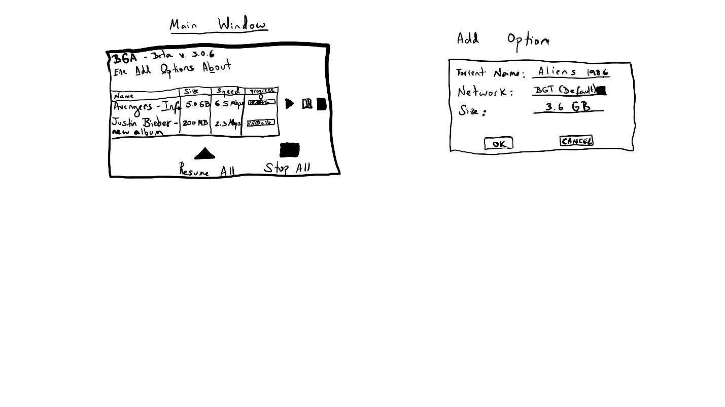

**Tasks completed/remaining/progress towards milestones:**

|  |  |
| --- | --- |
| Major task | Complete by date |
| Create and commit project solution - Done | 5/6/21 |
| Submit Status Report #1 - Done | 5/6/21 |
| Get started on GUI front-end in XAML – Done | 5/9/21 |
| Work on and complete peer evaluation #2 - Done | 5/15/21 |
| Continue working on GUI front-end in XAML – In progress | 5/31/21 |
| Work on back-end code and perform tests on application – In progress | 5/31/21 |
| Present project – To do | 6/5/21 |

**Something learned so far:**

Getting another person’s pov or critique is very helpful in improving the overall GUI.

**Current Issues:**

None.

**New Ideas/Redesigns:**

Got rid of basic/advanced modes and cleaned up design. User has the option to add a torrent from either a file or manually enter it from Add menu.

In addition, buttons for resume and stop have been repositioned.

**GIT commit of latest project code:**

Hash: 5be393d9419af579256f453b5295a51698158987

Tag: FinalProjectStarted